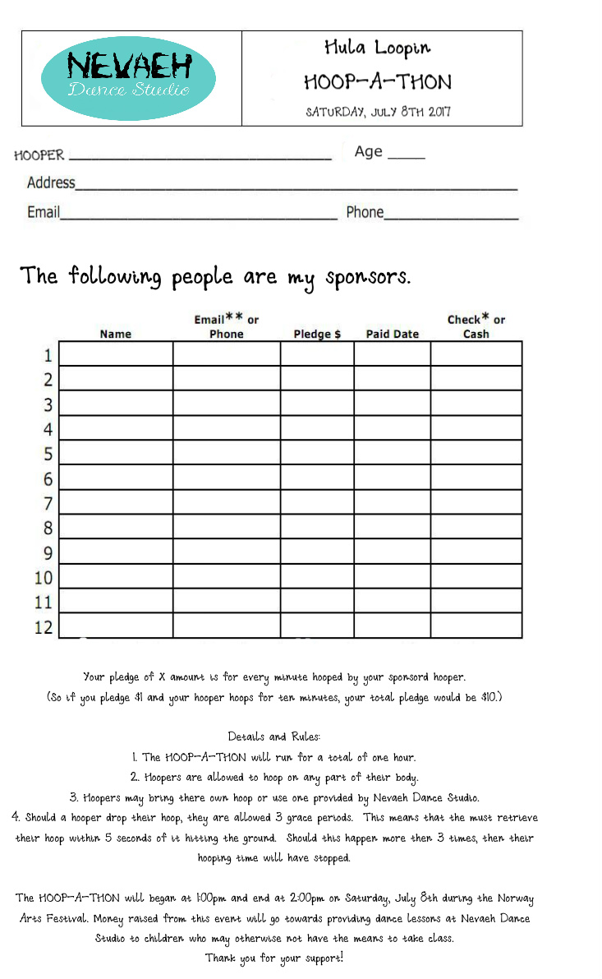
Your pledge of X amount is for every minute hooped by your hooper.
(So if you pledge $1 and your hooper hoops for a total of ten minutes, your total pledge would be $10. If your hooper were to complete the full hour, then your total pledge would be $60)

Details and Rules

- The HOOP-A-THON will run for a total of one hour.
- Hoopers are allowed to hoop on any part of their body.
- Hoopers may bring their own hoop or use one provided by Nevaeh Dance Studio.
- Should a hooper drop their hoop, they are allowed one grace period. This means that they may must retrieve their hoop right away and continue hooping. Should the hooper drop their hoop again, their time will have stopped.

The HOOP-A-THON will begin at 1:00pm and end at 2:00pm on Saturday, July 8th rain or shine during the Norway Arts Festival. This event will take place right on Main Street in front of Nevaeh Dance Studio. Money raised from this event will go towards providing dance lessons to students who may otherwise not have the means to take classes.
Thank you for your sponsorship!

